US Grade 5 – Pre-test
10 Questions | 30-45 minutes | Calculator allowed
1. What fraction of a meter is 20 centimeters?
- $\frac{1}{5}$
- $\frac{1}{20}$
- $\frac{1}{50}$
- $\frac{1}{100}$

2. Which expression shows 5 less than the quotient of 3 and 4?
- $5-3÷4$
- $3×4-5$
- $5-(3+4)$
- $\frac{3}{4}$$-5$

3. What are the coordinates of the point shown?
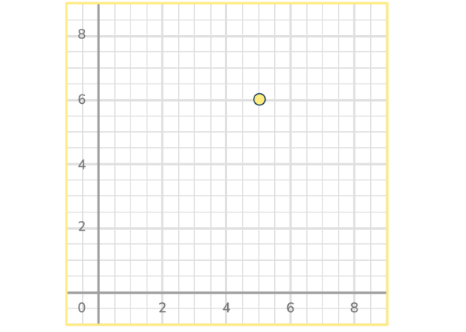
- (6,5)
- (6,6)
- (5,5)
- (5,6)

4. Harley has been measuring a plant for a science project. The flower has grown $\frac{1}{3}$ of an inch each week and has grown a total of 2 inches taller. How many weeks has Harley been measuring this flower?
- 6 weeks
- $\frac{1}{6}$ of a week
- 2 weeks
- 5 weeks

5. Yeva and her 3 friends go out to eat at a restaurant. At the end of the meal, the total bill is $72.36. They decide to split the bill equally. How much will each friend pay?
- $289.44
- $24.12
- $18.09
- $217.08

6. Which name(s) can this shape be classified with? Select all the correct answers.
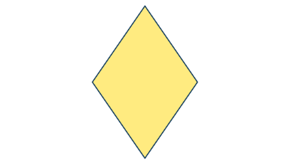
- Rhombus
- Rectangle
- Parallelogram
- Quadrilateral

7. Muhammad is getting new carpet installed in his bedroom. The diagram below shows the dimensions of his bedroom floor. If the carpet covers the entire floor, what is the area of the carpet?
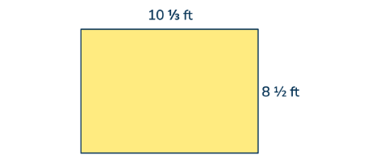
- 37$\frac{2}{3}$
- 87$\frac{5}{6}$
- 21$\frac{2}{3}$
- 76$\frac{5}{6}$
8. The composite shape below is made up of unit cubes. What is the volume, in cubic units, of the composite shape?
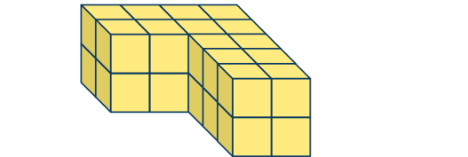
- 14
- 28
- 20
- 22

9. Miranda spent 2$\frac{3}{4}$ hours practicing teh drums. How many minutes did Miranda spend practicing the drums?
- 275 minutes
- 165 minutes
- 195 minutes
- 135 minutes
10. Complete the statement: 600 is _____ times the size of 60,000.
- 100
- $\frac{1}{10}$
- 10
- $\frac{1}{100}$

